Pb(II) adsorption onto dead B-culture

A seven page minimum-detail-rough-recap with pictures

# Initialisation

Initial experiments (50 mM NaN3)gave me an idea of how Pb removal is influenced by initial Pb concentration and biomass concentration). From figure b) it seems like max adsorption is about 2700 mg Pb(II) per gram bacteria, and this can be calculated with some isotherm model (like Langmuir, etc.). Also, looks like peak lead removal percentage occurs at a certain concentration; perhaps because higher concentrations overwhelm the adsorbent but lower concentrations don’t have a high enough concentration gradient.

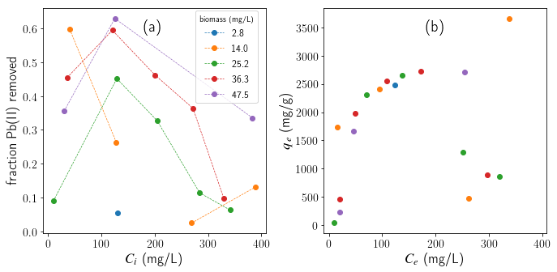

# Kinetics

The difference between living bacteria and dead bacteria Pb(II) adsorption starts to become apparent. Results from Carla’s masters could not be replicated with living bacteria, possibly indicating that her cultures contained a lot of dead bacteria. The shape of your temperature effects experiments seem similar to mine.

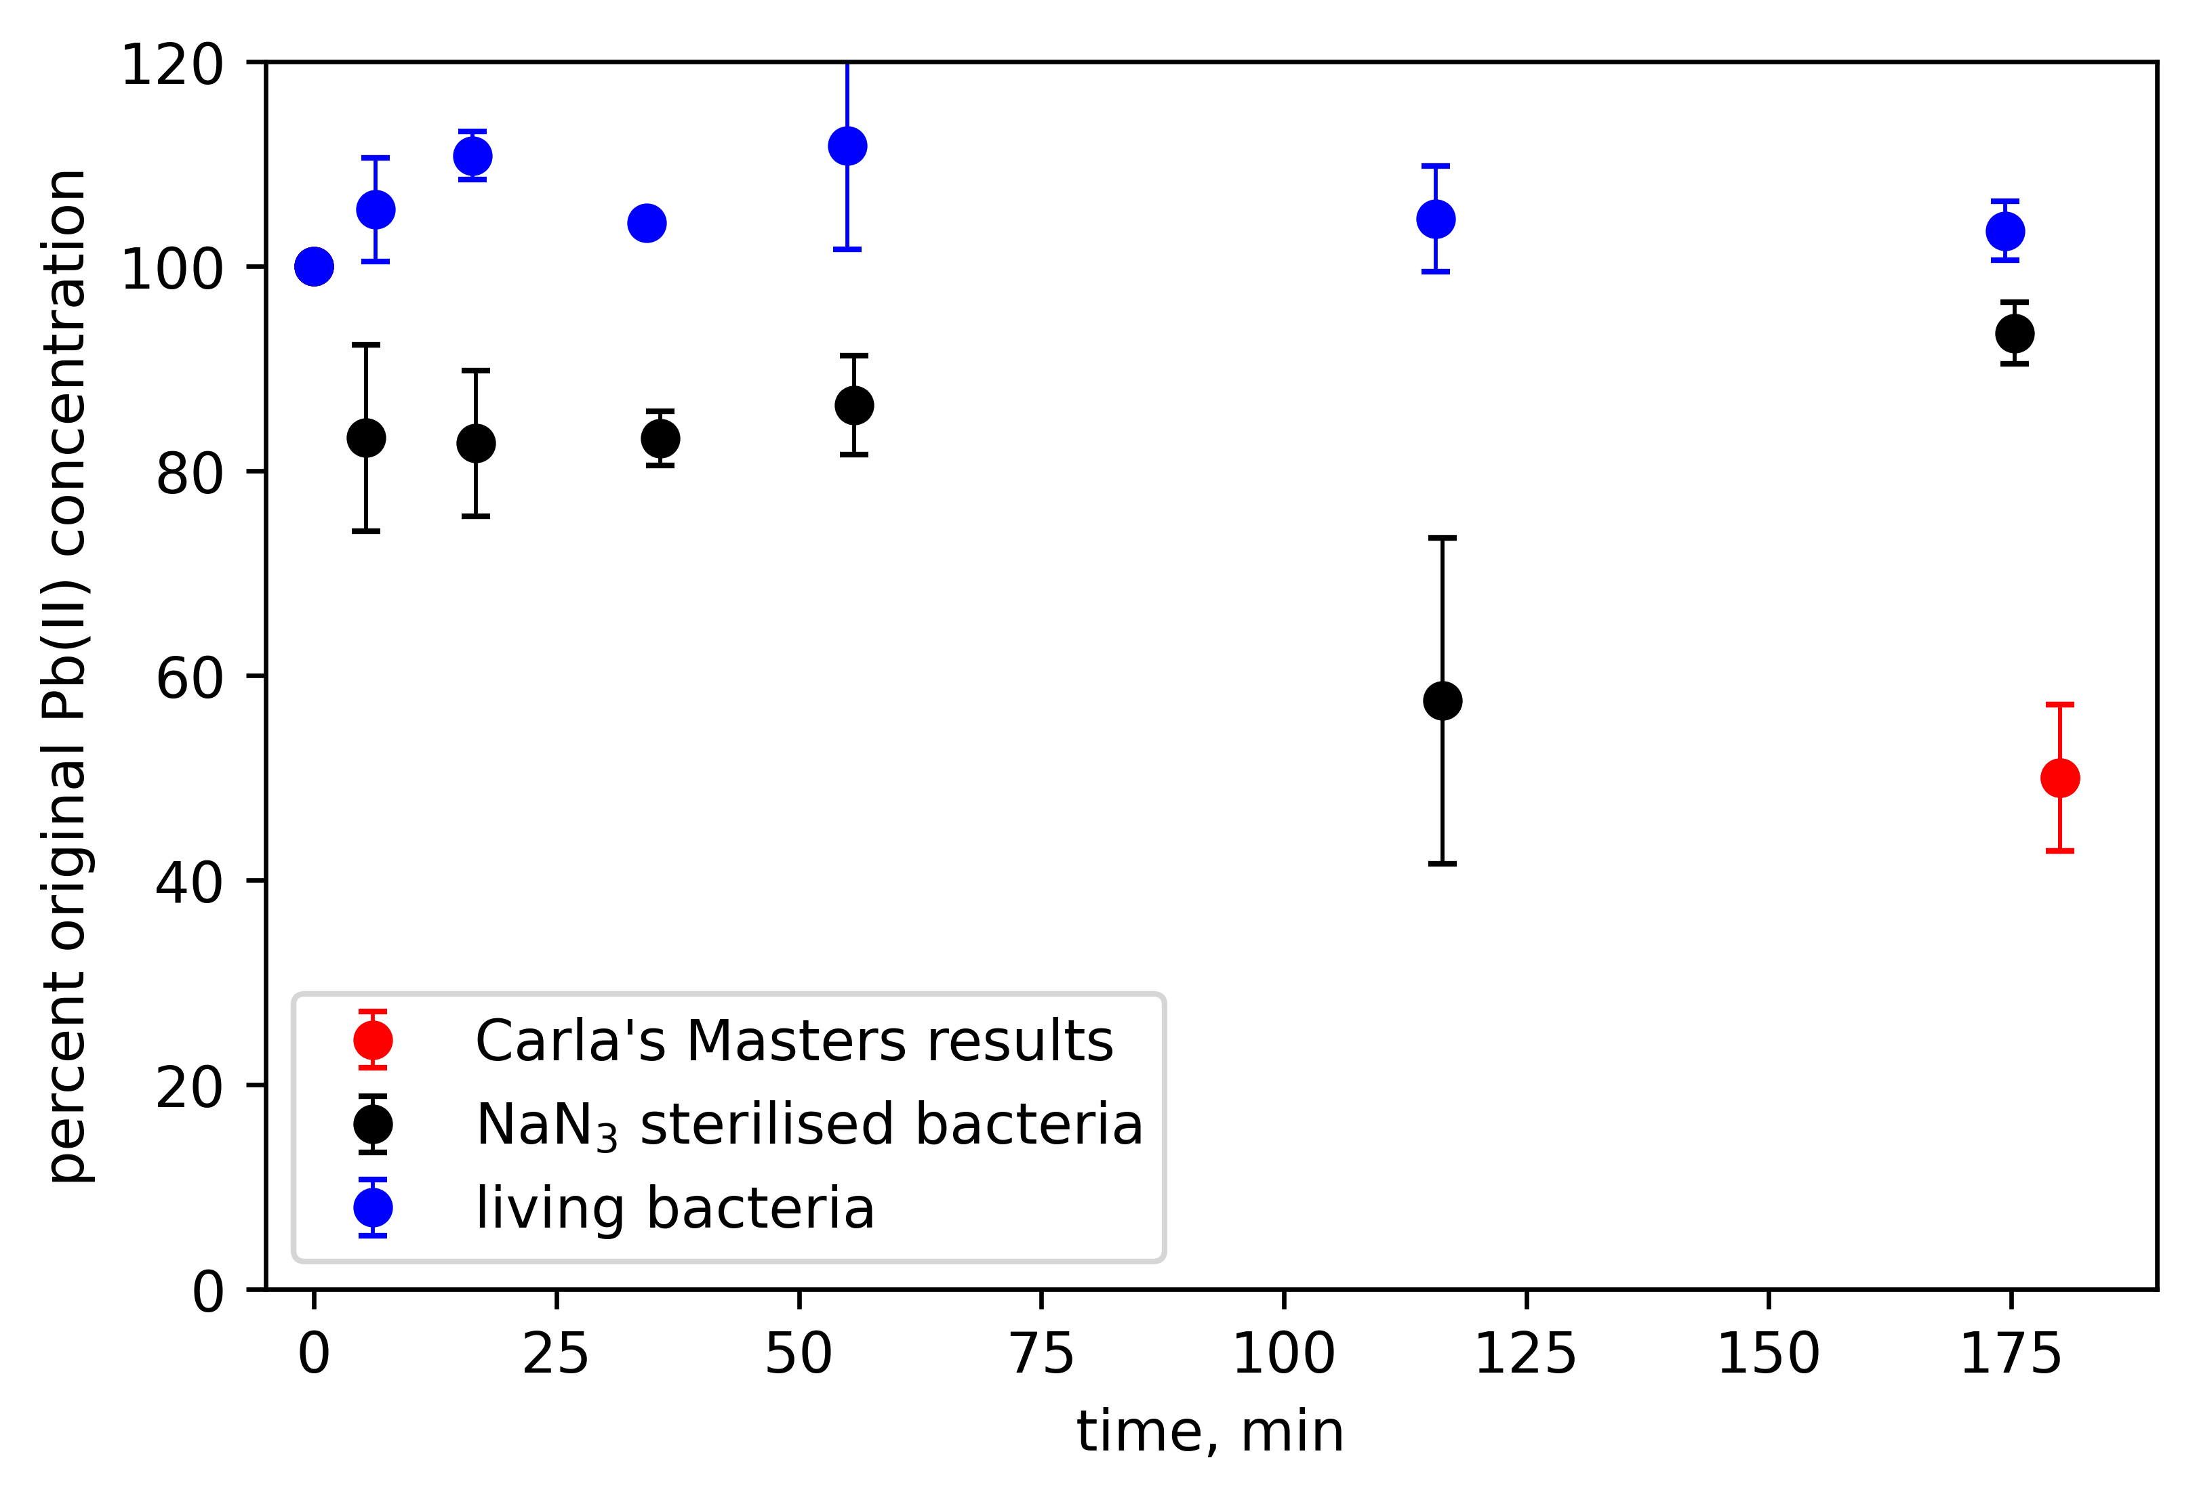

# **FTIR**

This was covered in the paper [Microbial Pb(II) Precipitation: the Role of Biosorption as a Pb(II) Removal Mechanism](http://dx.doi.org/10.3303/CET2186031), and gives insight into the different functional groups on the surface of the bacteria. It also showed that NaN3 does not affect the surface significantly.

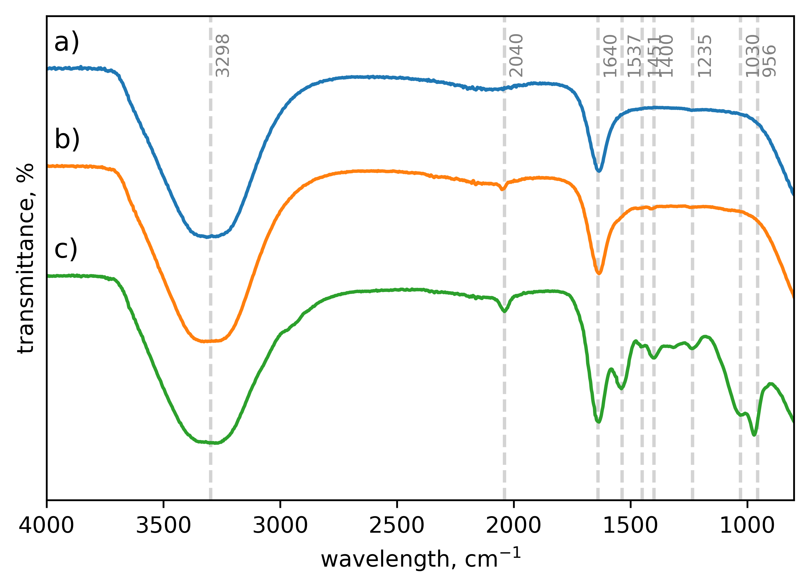

# **XPS**

This x-ray photo-spectroscopy was meant to investigate what mechanism is present in Pb binding. I discussed XPS in lead binding onto biomass at length in [High capacity Pb(II) adsorption characteristics onto raw- and chemically activated waste activated sludge](https://doi.org/10.1016/j.jhazmat.2021.125943). It has lots of potential, I’m just not sure I did it right.

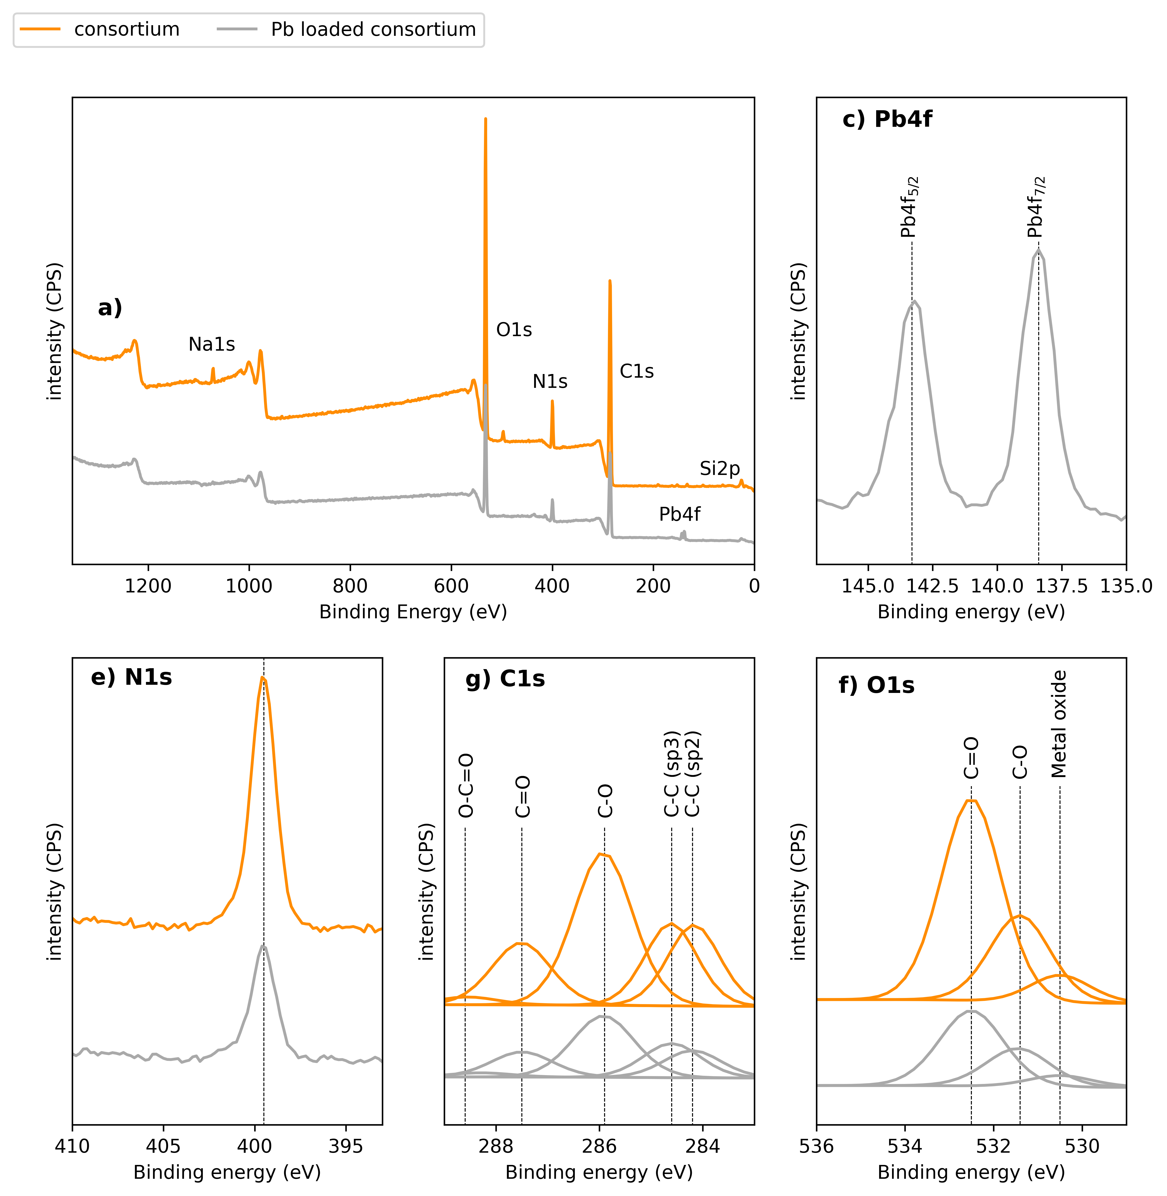

# Titrations

I did some titrations on the dead bacteria to try and gauge the acid-base site characteristics. These sites are very important as H+ competes with Pb2+ for adsorption. The titrations demonstrate how the pH of a bacteria-HNO3 solution changes when NaOH is added. Shown here is a look at how different concentrations of bacteria affect the titration:

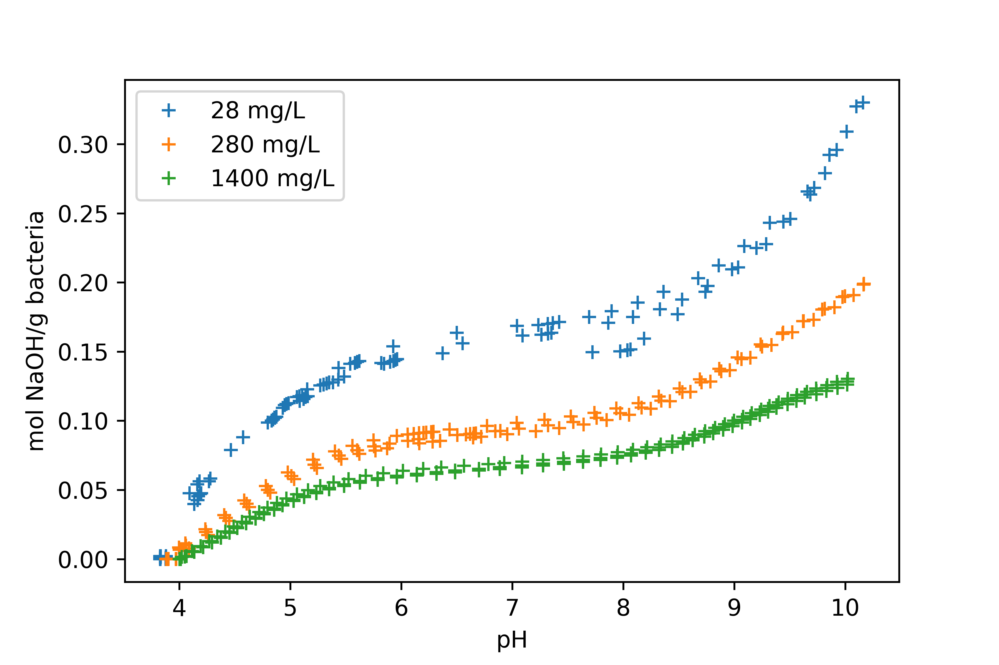With this titration data I fit different acid-base models in combination with different electrostatic models (see lit review). According to the results it looked like 4 different types of acid sites are present (one site would be −COOH → −COO- + H+ for example) and the Donnan shell electrostatic model (DSM) fits best. This is circled on the figure. There should be some info on the lit review about all of this, but its only important if you want to focus a great deal on modelling (or if you want some killer graphics).

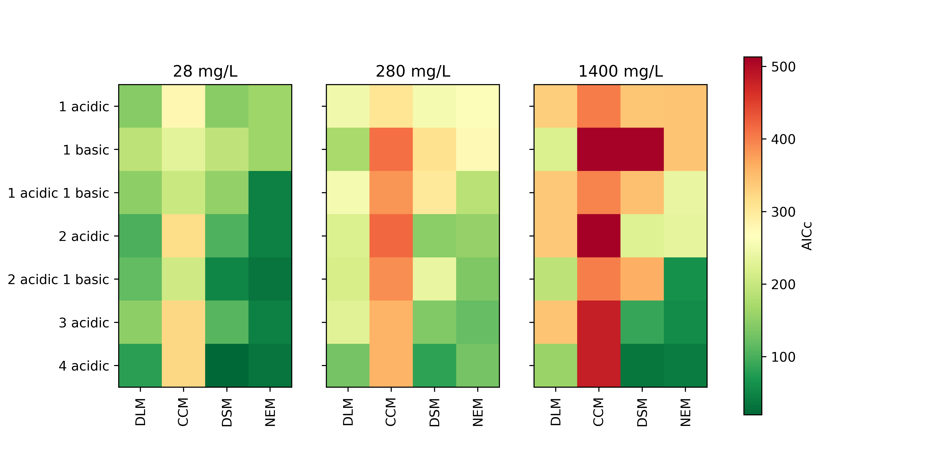

My other titrations tried to look at ionic strength (salt concentration) effects:

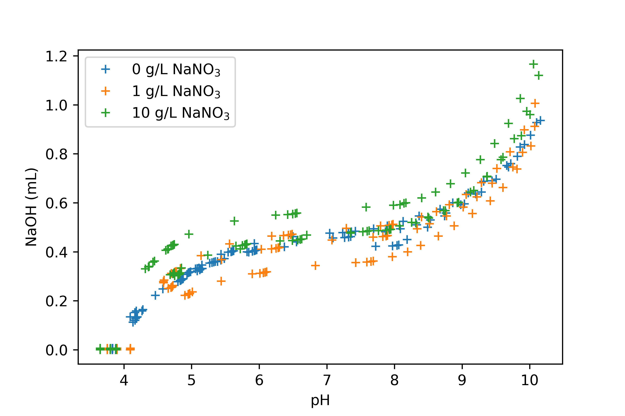

and how the presence of Pb(II) affects the titration curve:

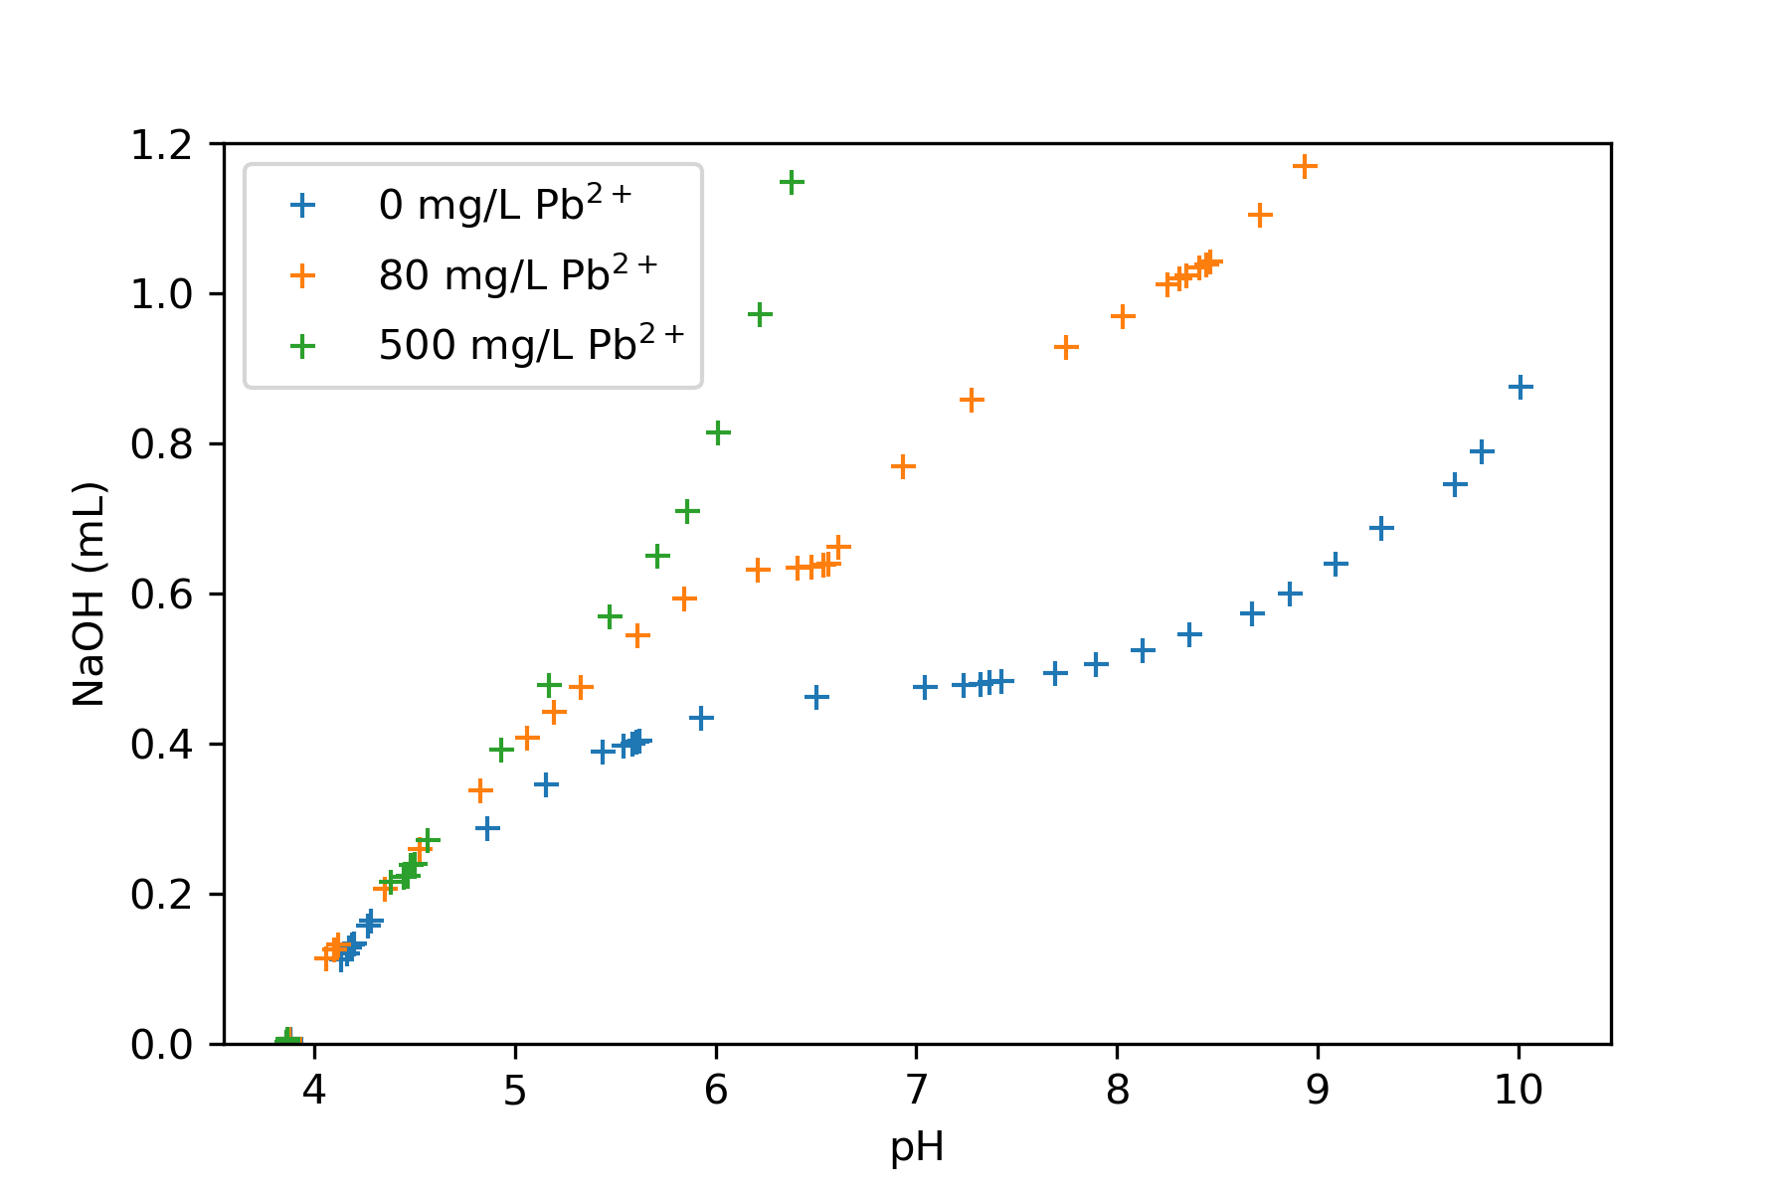

# Effects of NaN3 on cell viability

A plot twist! NaN3 does not even kill our bacteria! Even at ten times the recommended literature concentration, our consortium viability is reduced to only half. This might mean that all my previous research is somewhat invalid because I worked with *inhibited* and not fully *dead* bacteria. I had a little cry after this realisation, but it should have been my first experiment.

